EXP 9:

3D RECONSTRUCTION

**CODE:**

import cv2 as cv

from matplotlib import pyplot as plt

imgR = cv.imread('right1.jpg', cv.IMREAD_GRAYSCALE)

imgL = cv.imread('left1.jpg', cv.IMREAD_GRAYSCALE)

stereo = cv.StereoBM_create(numDisparities=16, blockSize=15)

disparity = stereo.compute(imgL, imgR)

plt.imshow(disparity, cmap='gray')

plt.colorbar()

plt.show()

**INPUT:**

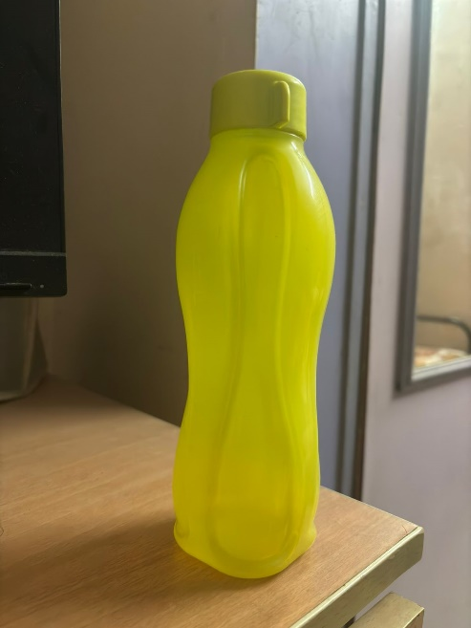 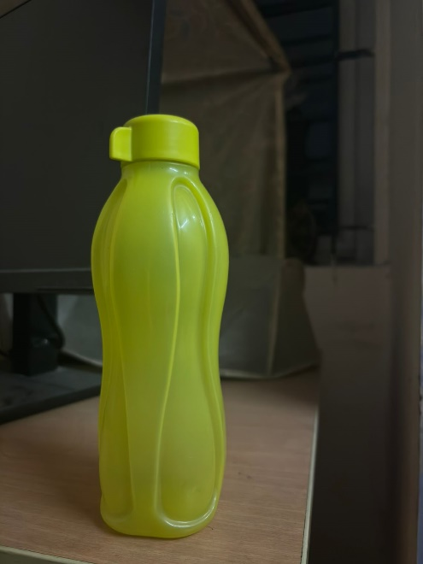

**OUTPUT:**

